**NOTE: Fill this document according to the requirements that you have identified in your analysis and brain storming.**

Software Requirements Specification

For

H2Order: Smart Ordering and Monitoring for Water Refilling Businesses in Nasugbu, Batangas

**Version 1.0 approved**

**Prepared by:**

**Relano, Kurt Michael**

**Rangel, Ivane Kielle**

**Sevilla, Dave Bryan**

**BROSCODE**

**July 12, 2021**

**Table of Contents**

**Table of Contents ii**

**Revision History ii**

**1. Introduction 1**

1.1 Purpose 1

1.2 Document Conventions 1

1.3 Intended Audience and Reading Suggestions 1

1.4 Project Scope 1

1.5 References 1

**2. Overall Description 2**

2.1 Product Perspective 2

2.2 Product Features 2

2.3 User Classes and Characteristics 2

2.4 Operating Environment 2

2.5 Design and Implementation Constraints 2

2.6 User Documentation 2

2.7 Assumptions and Dependencies 3

**3. System Features 3**

3.1 System Feature 1 3

3.2 System Feature 2 (and so on) 4

**4. External Interface Requirements 4**

4.1 User Interfaces 4

4.2 Hardware Interfaces 4

4.3 Software Interfaces 4

4.4 Communications Interfaces 4

**5. Other Nonfunctional Requirements 5**

5.1 Performance Requirements 5

5.2 Safety Requirements 5

5.3 Security Requirements 5

5.4 Software Quality Attributes 5

**6. Other Requirements 5**

**Appendix A: Glossary 5**

**Appendix B: Analysis Models 6**

**Appendix C: Issues List 6**

**Revision History**

|  |  |  |  |
| --- | --- | --- | --- |
| **Name** | **Date** | **Reason For Changes** | **Version** |
|  |  |  |  |
|  |  |  |  |

# Introduction

## Purpose

### H2Order: Smart Ordering and Monitoring for Water Refilling Businesses in Nasugbu, Batangas was designed to improve databases, to provide easy access to delivery of water, to add the total water deliver every day, to compute the customer orders, to input details and information of the customer, to schedule a monthly water level inspection, to print reports and to reduce physical contact with others.

### Furthermore, the improvement of ordering and delivery method eliminates costs, time, and money and its advancement scheme for the operation of workers, customers, merchants and administrators of the water refilling station.

## Document Conventions

The documentation convention that we used are:

* Font Style: Times New Roman
* Font Size: 13
* Spacing: Double Spacing
* Reference format: MLA or Modern Language Association

## Intended Audience and Reading Suggestions

The expected audience that relates to our program or system will be the admin, merchants, customers and the system developer and those who are belong to the business field of water refilling stations. The benefits of the system would be beneficial to all audiences and also the given purpose of the study would be effective and reliable.

## Project Scope

### Account Module applies to the storing and managing of customers' and merchants' accounts, which are organized in order to store all of the data. It also contains account management and settings such as the username and password.

### Ordering Module contains all the water refilling stations, types of water, seller’s and customer’s information and order history which allow to have transparent and good transaction.

### Inspection and Monitoring Module contains all the assessment regarding the water quality, monthly results of Alpha Lab testing, Medical health card of the employees and the prescribed health standards.

### Report Module will produce evaluation and monitoring reports based on data entered from all device modules. This module is available to admin and merchants. It also enables the merchants to print hardcopies of the reports they require.

### Analytics Module manages a cohesive list of accredited water refilling stations and also features a filtering of all water refilling stations by barangay of Nasugbu, Batangas.

### Ratings and Review Module consist of all feedbacks, response and suggestion of the customer based on the quality and services provided by the various water refilling station.

## References

# Overall Description

## Product Perspective

Water is essential to the human body. Water was being used by all of the cells, lungs, and tissues to assist with temperature control, staying hydrated, and regulating bodily functions. Water also serves as a lubricant and cushions the joints. Drinking water is beneficial to our physical wellbeing.

Since our body loses water by respiration, sweating and digestion. Drinking water and consuming food that contain it was very important that we are rehydrate. It is obvious to us how important water is to our human life.

H2Order: Smart Ordering and Monitoring for Water Refilling Businesses in Nasugbu, Batangas is intended to improve the manual ordering and delivery method of every water refilling station here in Nasugbu, Batangas. In addition, it can help the customers to order easily and conveniently to reduce time and effort to go directly to the Water refilling station towards efficiency and productivity of the transaction.

## Product Features

The major features of the H2Order: Smart Ordering and Monitoring for Water Refilling Businesses in Nasugbu, Batangas as shown in below entity-relationship model (ER Model)

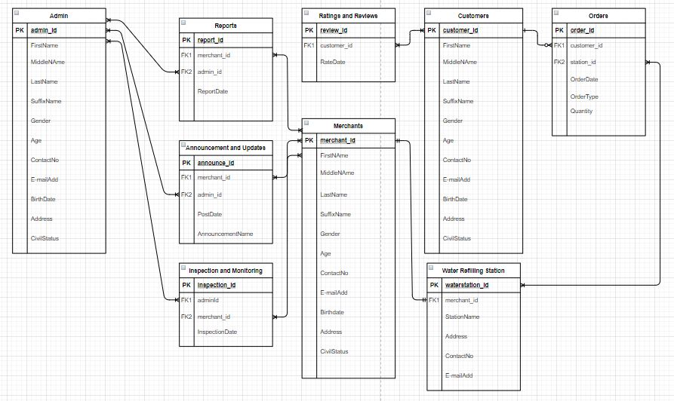

## User Classes and Characteristics

There are three types of users: the Admin, Merchants and Customer.

### Admin.The system will help the department to observe the accredited stations if the workers follow and practice the given health protocols. And manage the accordance of quarterly report.

### Merchants. The system will help them to monitor the deliveries and manage the transaction with the customers. The system also help to guarantee the work efficiently. And handles shortcomings from the customers that may affect their business.

### Customers. The system will help to reduce the time and effort in searching for the nearest water refilling station. It can also monitor the transaction history and their payments. Also to provide honest review and feedback regarding to the quality and service of the staff.

## Operating Environment

The system will be require a hardware platform such as a laptop on development of the H2Order: Smart Ordering and Monitoring for Water Refilling Businesses in Nasugbu, Batangas. The requirement is a laptop with 4GB RAM, 2.0 ghz processor and a 500GB storage. Also, a keyboard and a mouse.

## Design and Implementation Constraints

In every plan there are always problem like the following given under: the system is align to the sanitation of the Municipality of the Nasugbu wherein the information may be confidential, some merchant may refuse to associate with the system, the hardware also can be a problem when it would have any malfunction or any error upon operating. Lastly, while in developing the system the maintenance and other requirement may face various complexity and challenges that should not be ignored.

## User Documentation

In order to have reliable output, the related studies, context, journals and articles will be helpful to gather accurate and dependable information in order to have a good and effective system.

## Assumptions and Dependencies

The following factors are the constraints may be encounter such as the company procedures, equipment, involve audience and also required software. Company procedure may be related to the security of the information and other transaction that is definitely private. Next, the equipment that will be used as assume every equipment may encounter downtime that cause inefficacy and unreliable. Third, the involve audience also be a constraint since they may associate with the plan and also to the system. Lastly, the required software may give different outcomes which may be contradict to the plan.

# System Features

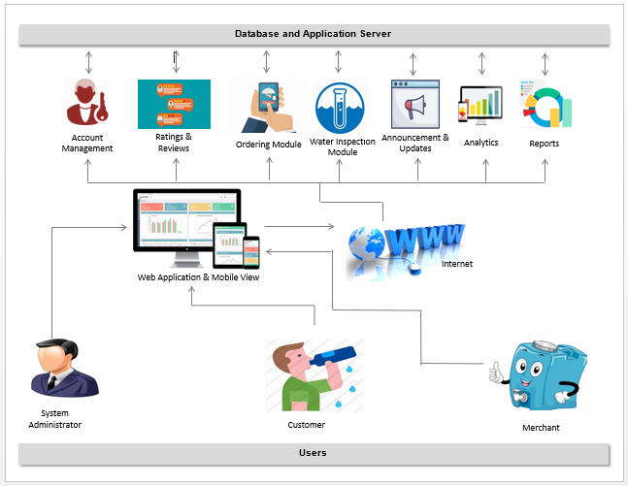

## Login Form

3.1.1 Description and Priority

This feature will be an essential aspect of the H2Order: Smart Ordering and Monitoring for Water Refilling Businesses in Nasugbu, Batangas as it will access security in terms of user connectivity between the admin, merchant and the customer. Also, it allows the authentication of each account from all types of attacks for unauthorized persons. This would be a high priority feature on the level 9 priority scale, especially the system is dealing with a large amount of private data and information.

3.1.2 Stimulus/Response Sequences

Users who will interact with the system intent to register to have their account profile. Then, the user may add his/her specific information such as their name, home address, contact number and etc. After that they will choose badge if they are a customer or a merchant as along with a Valid ID for authentication and confirmation to prevent any phishing and illegal activities. Lastly, the data privacy agreement as well as the end user agreement that need to acknowledge in order to have transparency.

3.1.3 Functional Requirements

The following are the legal standards for this feature in order access the authentication form: first, a valid user ID and second, a valid user password. If a certain user enters an invalid password and a user Valid ID, the system will immediately appear a dialog box with a details about invalid input and the user will be instructed to re-attempt to login.

REQ-1: USERID

REQ-2: USERPASSWORD

## Ordering

### Description and Priority

This feature is also important component to the system which generally deals with the transaction which is the key purpose of the H2Order: Smart Ordering and Monitoring for Water Refilling Businesses in Nasugbu, Batangas. This feature is also the high priority with a scale level 9 which concerning to the significant function of the system.

3.2.2 Stimulus/Response Sequences

Users who will interact with the ordering function will execute the following activities such as order details, product type, customer credits, email and SMS notification, order monitoring and Merchant location. As a customer they will their desired product to the various authorized water refilling station with its location in order to monitor and track their order details. Also, along with the ordering process an e-mail or SMS notification will be sent to the customer.

3.2.3 Functional Requirements

The ordering feature's fundamental requirements are the consumers' and merchants' data and information, followed by the quantity of product stocks required to initiate the process and function. Because it is intended to reduce the amount of time and energy involved by the consumer to order the water they needed. As well as for merchants who prefer to sell their products and services online. This feature lay out a dialog box containing all the information of each user and asking actions for the decision making.

REQ-1: Account information of the consumer and merchant

REQ-2: Quantity of the product and its service

## Water Inspection

### Description and Priority

This function is in charge of monitoring the sanitation and cleanliness of the system's registered water refilling merchants. Additionally, each merchant will undertake a lab test and submit a report to the system's administrator. The scale level is also nine, as this is the primary objective of the system's structure.

3.3.2 Stimulus/Response Sequences

Merchants who interact with the water inspection must take the following requirements: laboratory results, employee medical reports, water station details, and finally, dress code and health protocol reports that will be forwarded to the system administrators in order to maintain safe and healthy water.

3.3.3 Functional Requirements

This feature's primary requirement is for each water refilling station to submit reports and results in order to continue making transactions with the system. Additionally, these requirements help to ensure that almost all water refilling stations provide a high-quality product and a safe environment for their customers.

REQ-1: Report of the Merchants and Workers

REQ-2: Results of Alpha Lab test

# 

# External Interface Requirements

## User Interfaces

**Customer Interface**

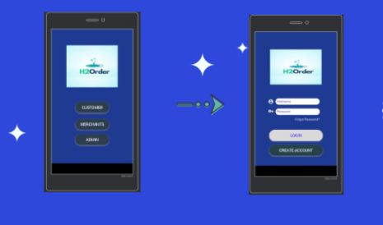

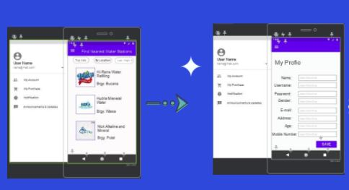

**Merchant Interface**

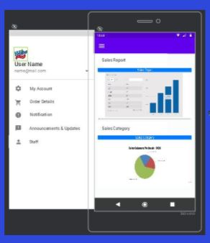

**Admin Interface**

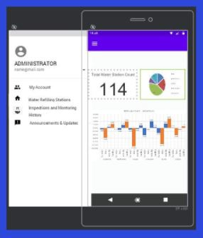

## Hardware Interfaces

For hardware interfaces that the group will be using is the computer or laptop in the product creation and as well as in accessing the websites in web browser by using the HTTP communication protocol.

## Software Interfaces

*The system will be linked to other software components such as the XAMMP MYSQL database version 7.4.20, which will be responsible for the container or storage of our data inputs using the system. It will also serve as a way to connect login form to user interfaces.*

## Communications Interfaces

The requirements associate with the products is web browser for accessing and viewing websites or the developed product. And the communication standards that will be used is the HTTP or the Hypertext Transfer Protocols that allows user to communicate and transfer data on the World Wide Web.

# Other Nonfunctional Requirements

## Performance Requirements

The system analysis will provide the requirements for the system and to check if the system working properly. Conducting software testing in other groups to know what features that can easily for them to use or to perform a job easily with no hesitation and hassle.

## Safety Requirements

The possible loss or damage of the system is the overload of data input in the database, interruption in losing connection while inputting data in the system, this must be prevented by always have a backup for the data while typing when the website or the system reload the data input are saved.

## Security Requirements

The system must only access by the employee in a restaurant or hotel, it also has an authentication prompt to those people who tried to access the system that are not employed in the organization.

## Software Quality Attributes

The quality characteristics of the product that will be important to either the customers or developers are system reliability, usability, and functionality. Reliability for the correct performance of the system at the specific time so it will not cause a problem to the user and developer. Usability so the product will be usable to the users. Lastly, the functionality define the behavior of the system. If the system is functional it will benefit both the user and developers and will not cause problem to them.

# Other Requirements

Database is one of the important components of the system because its function is to hold the data. It is the storage of data and information that the user store in it wherein the user can retrieve, modify, and delete data based on the data-processing operations. A database management system (DBMS) extracts information from the database in response to queries. It uses a combination of one-to-one, one-to-many, many-to-many connection to create multiple queries.

**Appendix A: Glossary**

**Admin** - a person legally vested with the right of administration of an estate.

**Customer** is a person or company who purchases goods and services. A customer becomes a consumer when he or she uses the goods or services where there is some consumption

**Delivery** refers to the act of transferring a commodity, services, products, currency, security, cash or another instrument that is the subject of a contract. It is often used in relation to [derivative contracts](https://www.investopedia.com/terms/d/derivative.asp) such as futures and options.

**Feedback** refers to the information that comes directly from customers regarding their satisfaction or dissatisfaction with a product or service. Feedback allows businesses to keep track of their success.

**Municipality** is a political division of a State in which a municipal corporation was set up to provide general local government for certain concentrations of the population in a given region.

**Owner** is an individual who owns and operates a business, small or large, with the aim of deriving profit from its successful operation

**Transaction** is a completed agreement between a buyer and a seller to exchange goods, services, or financial assets. But in business bookkeeping, this plain definition can get complicated.

**Water Refilling Station** is a type of business that provide a cheaper and safe public water for the community. This may be managed by private individuals that comply with the health standards.

**Appendix B: Analysis Models**

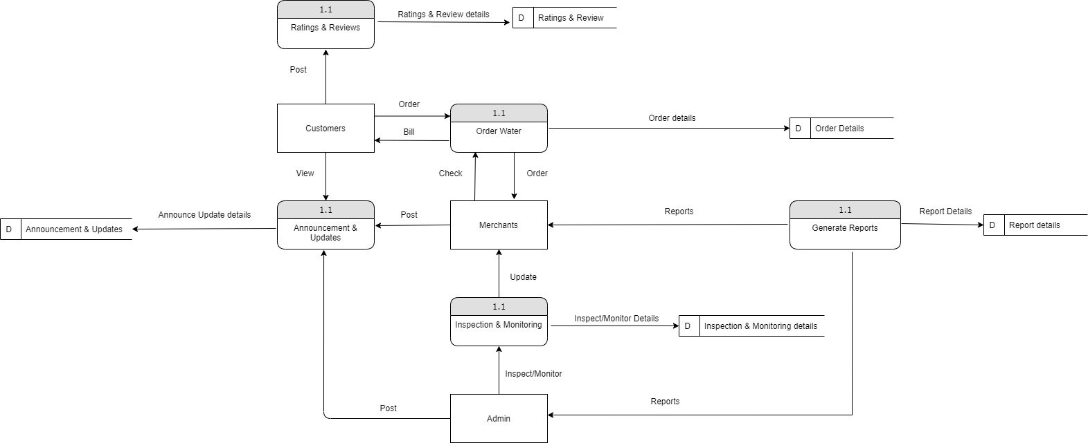

**Appendix C: Issues List**

The list of issues we see that need to be resolve are:

* Pending development of other features
* Problem in the functionality of some features
* Connection of database for some features
* System Design Enhancement